Week 8 lecture
Mocking
- Faking parts of a system
- E.g. using fake apple to test item scanner that should identify it as a “real apple”
- Code:
  - “from unittest import mock”
  - @mock.patch(‘src.user_input.read_string’)
    - We want to alter the method “src.user_input.read_string”
    - Creates a fake version of this method
  - Side_effect attribute:
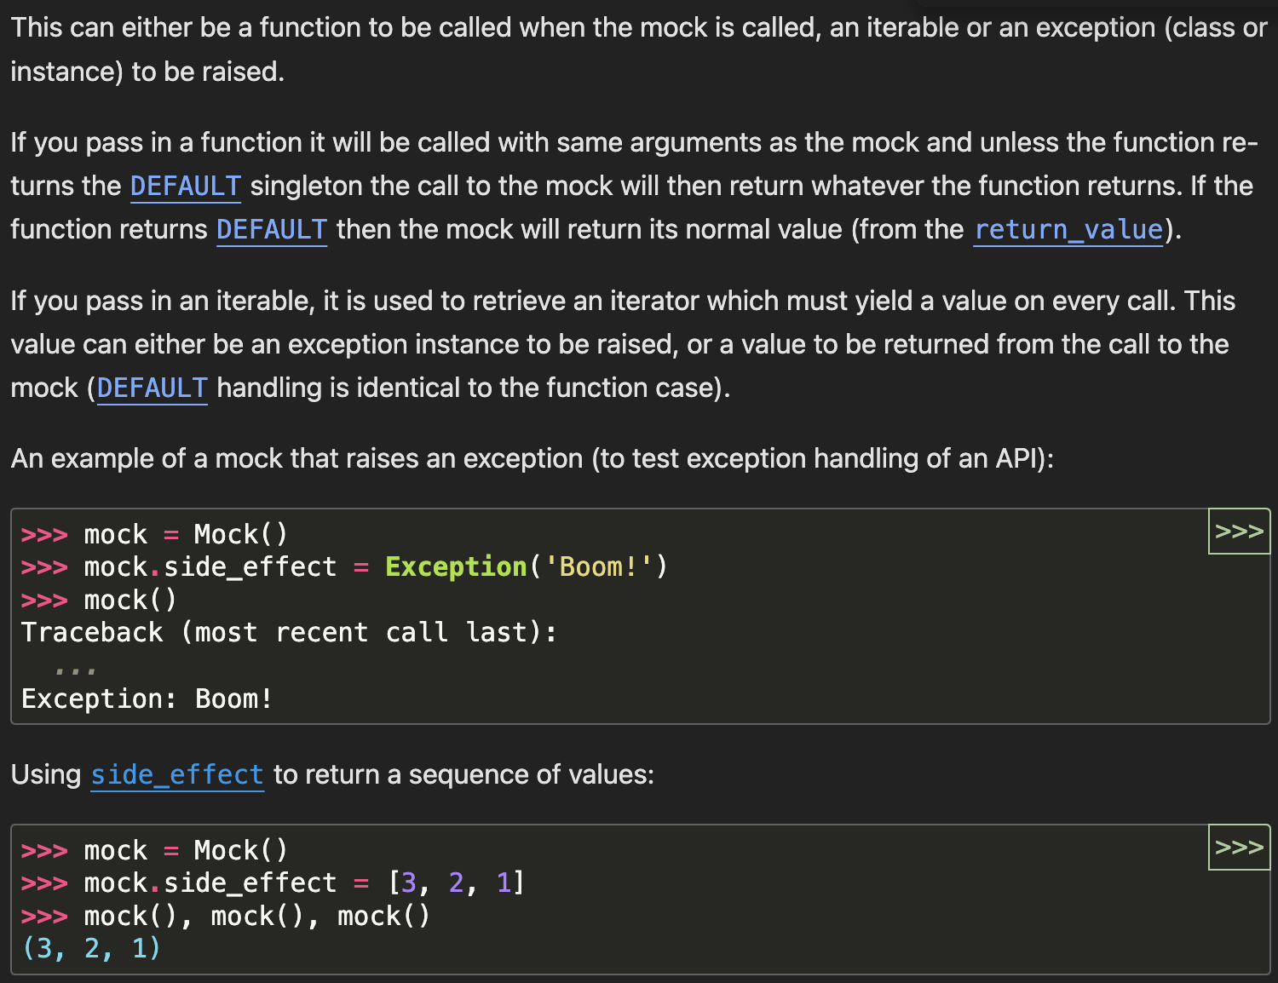
Dynamic Behavior Based on Input: You can define a custom function using side_effect to return different results based on the input arguments passed to the mocked function. This makes the mock behave more like the real function it is standing in for.
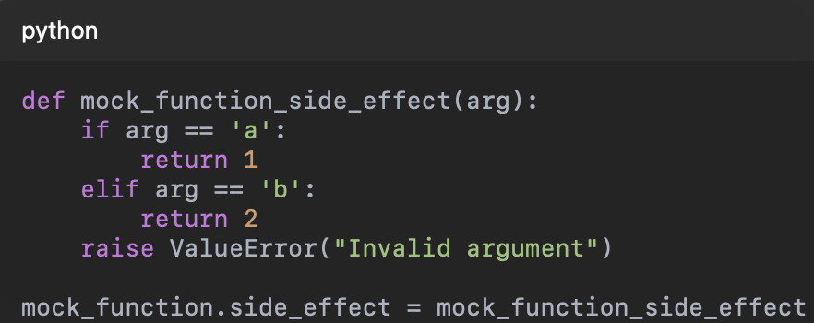
Now, calling mock_function('a') returns 1, and mock_function('b') returns 2. If an invalid argument is passed, it raises a ValueError.

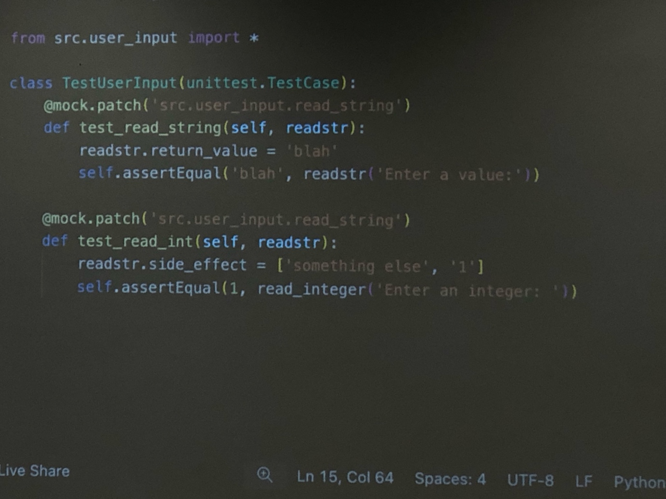
- Introduces a new set of maintenance issues
  - Accurate?
  - Up to date?
+ if the sys is complex but you don’t need to understand it
+ isolate the code you’re testing
+ when you need user input
+ real sys too slow
+ real sys costs money to use
+ real sys too random (need a deterministic environment to test this component)
+ too difficult to set up organically (need 100C weather)
+ can’t access real sys
+ don’t have the right hardware
Stubs gives a canned response no matter what
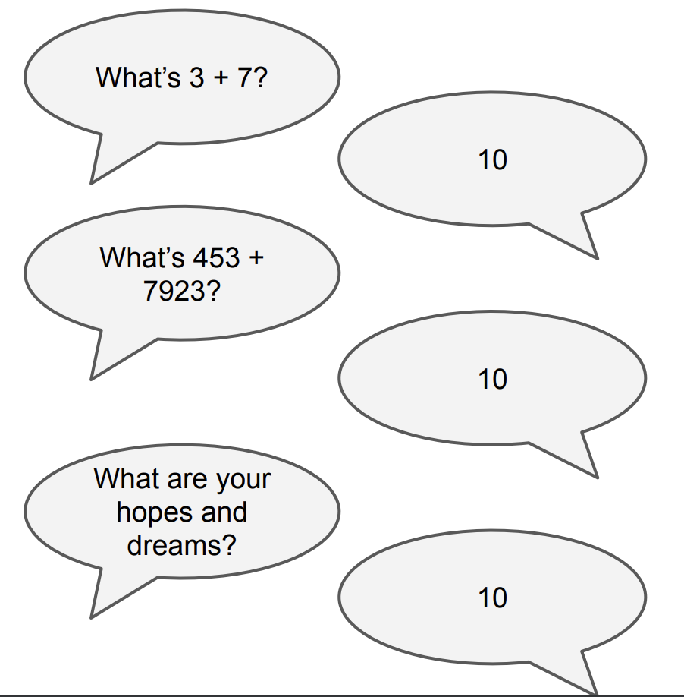

Fake fake is anything you add just to facilitate testing
Mock has behaviour
